[This template is provided to help standardise “Description of Methods” submissions for datasets contributed to the GlaMBIE project. It should be uploaded as PDF as part of the data submission through the data portal. Please complete all sections. The information you provide will accompany your dataset and be included in the supporting information of the GlaMBIE-2 paper.
- Keep each section concise, the document should not exceed 4 pages.
- A method reference with DOI is mandatory by the time the GlaMBIE paper gets published.
- If your dataset deviates from the published method, please clearly describe how.
- You may submit an updated version of this document at any point before the GlaMBIE paper is published.]

Description of Methods

Data submission group name: [e.g. First_author et al]

1. Method Reference
[Provide the reference to the peer-reviewed publication describing the method, including DOI. If the method has not been published yet, please note your plan and timeline for publication. Note that for your dataset to be included, the method of your dataset needs to be published BEFORE the GlaMBIE paper gets published (~Q1 2027).
Example: Smith et al., 2022. Title of Paper. Journal of Glaciology, DOI: 10.xxxx/xxxxx]

2. Summary of Method
[Provide a short summary of the method.
If your dataset departs from the published method (e.g. parameter adjustments, different input data), describe the differences clearly.]

3. Summary of Data Coverage
[Please describe: (1) spatial coverage, (2) temporal coverage, and (3) hypsometric coverage
Please provide figures which indicate coverage of the submitted dataset (see an example in Figure below).

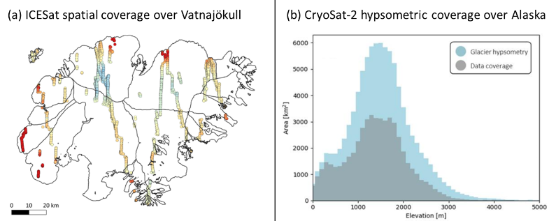 Example figures of (a) spatial coverage of a dataset (adapted from Berthier et al., 2023) and (b) hypsometric coverage of a dataset (adapted from Jakob et al., 2021). Dataset submissions should contain similar figures within their methods description.]

4. Summary of Uncertainty Estimation
[Describe how uncertainties were assessed, quantified and propagated.
Note any assumptions made.]

5. References
[Any references cited within the document]

